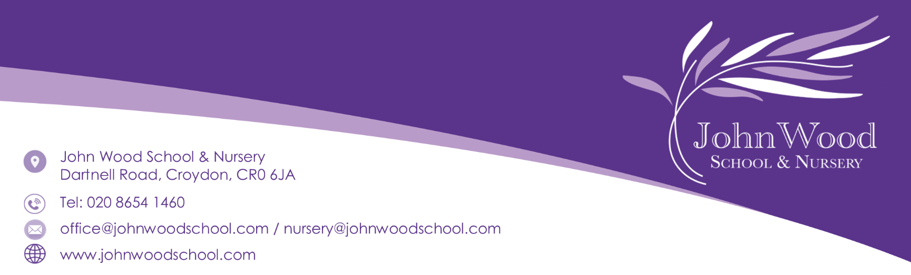
NURSERY SCHOOL INITIAL APPLICATION FORM A
Please use block capital letters

Name of Child:
Date of Birth: |  | Male ☐ Female ☐
Home Address:
Parent’s Name:
Mobile Number:
Email Address:

Does your child have any Special Educational Needs that we should be aware of? | Yes ☐ No ☐

If yes please give us some brief details:

Languages spoken at home:

Preferred Session: AM (8.40- 11.40) ☐ PM (12.40 - 3.40) ☐ FULL TIME (8.40- 3.40) ☐

Part time children will attend either 5 mornings or 5 afternoons per week.

Please note that we are not always able to offer the session of your choice.

For full time children, the lunch hour session is not included in the 30-hour child care funding and it is the parents/carers responsibility to pay for these, in advance.

For part time children, we are offering an additional hour for lunch between 11.40 and 12.40. Children in morning nursery can stay for lunch and those in the afternoon nursery can start earlier and have lunch before their session. Please note that 48-hour notice is required.

The lunch session costs £6 per day payable in advance and this includes a hot meal from our school catering team. Please note that allergies and medical/religious dietary requirements are always catered for.

Please indicate below if you would like your child to stay for additional lunch hour

I would like my child to stay for lunch at nursery either at the end of the morning session or at the beginning of the afternoon session (whichever they attend).
☐ Monday ☐ Tuesday ☐ Wednesday ☐ Thursday ☐ Friday

Please note that payment for the lunch session would need to be made in advance.

Once we receive this application it will be processed in accordance with the age and start date of your child. A full application form will need to be completed, nearer the time of your child’s offer date.

Children will be admitted the term after their third birthday (see below). The child will then have access to the 15 Universal free hours Government funding for three and four year olds or 30 hours free childcare, if eligible. Children born between:

- 1st January and 31st March will start in April.
Places allocated and notified before February Half Term
- 1st April to 31st August will start in September.
Places allocated and notified before May Half Term
- 1st September to 31st December will start in January.
Places allocated and notified before October Half Term

All our nursery places are part-time and full time. The part time children are offered for either five mornings or five afternoon sessions per week during term time.
- Morning sessions: 8.40-11.40am
- Afternoon sessions: 12.40-3.40pm
- All day session: 8:40-3.40pm

However, if a parent/carer wishes their child to start during the term of their third birthday, this may be possible if places are available. This will be charged at a cost of £90.00 per 5 sessions weekly (£18 per 3 hour session).

Application

If you wish to apply for a place at John Wood Nursery, please complete this form and return the application with a current proof of address via email at nursery@johnwoodschool.com or to the nursery, main school office or send to:

John Wood School & Nursery
Dartnell Road
Croydon
CR0 6JA

Once you have been offered a place, you need to come to our main nursery office with proof of your child’s age (passport or full birth certificate) and a recent utility bill. You will be required to complete Admission and All About Me Forms for our records. If a place is not available, your child will be placed on our waiting list. For further information on our admission criteria, please see our Admission Policy on our website.

